# Detailed Observations and Recommendations

## Building P1 Floor 1

RF Observation summary:

Overall RF Cover and SNR is not good at gray area.

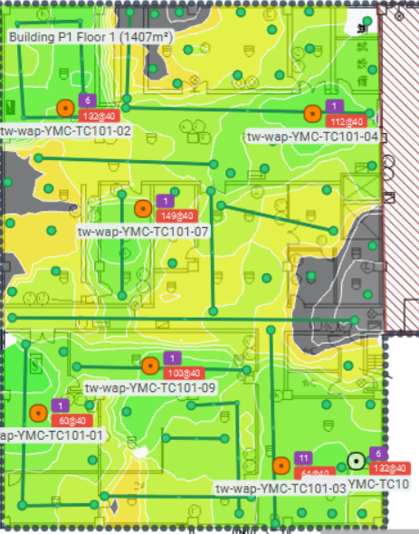

Recommend installing one AP as marked green.

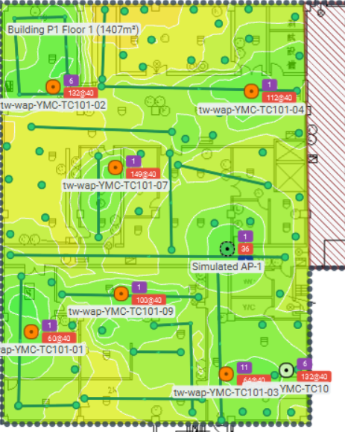

Channel interference on 5GHz band is moderate.

No interfering WAP in this area.

## Building P1 Floor 2

RF Observation summary:

Overall RF Cover and SNR is not good at gray area.

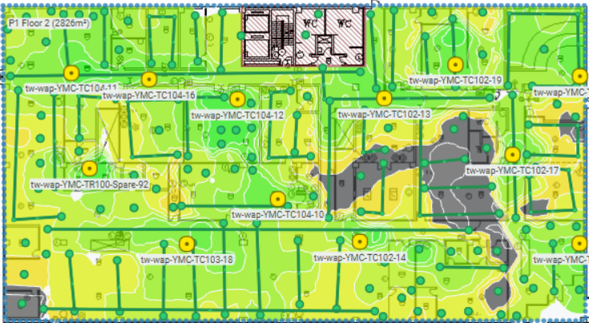

Client request to add AP for Lab area as marked red.

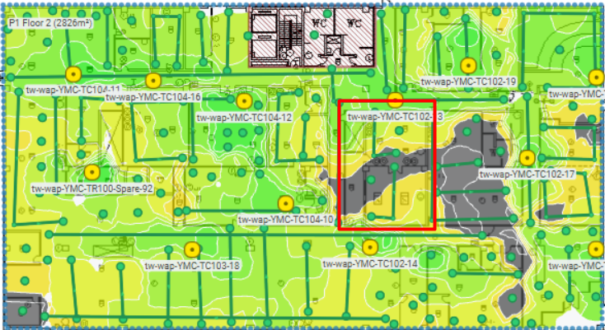

Recommend installing one AP as marked green.

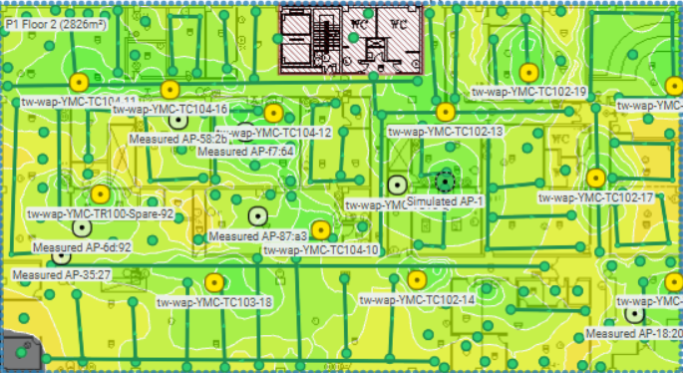

## Building P1 Floor 3

RF Observation summary:

Overall RF Cover and SNR is not good at gray area.

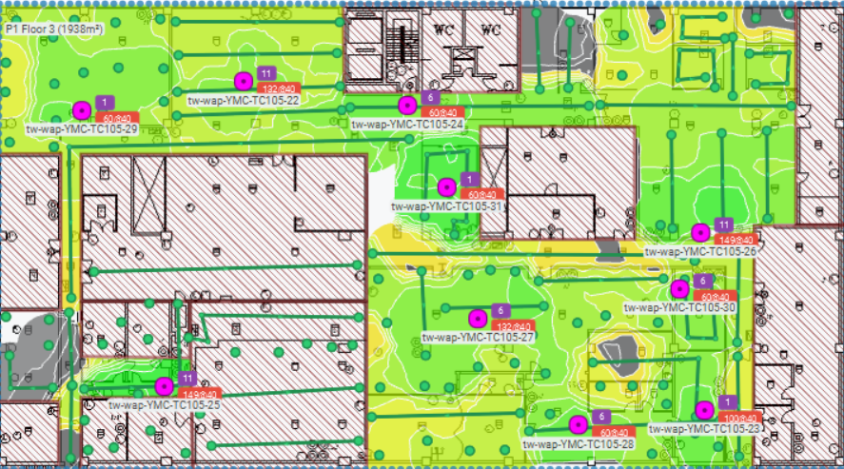

Recommend installing two APs as marked green. The location of Simulated AP-2 is requested by user.

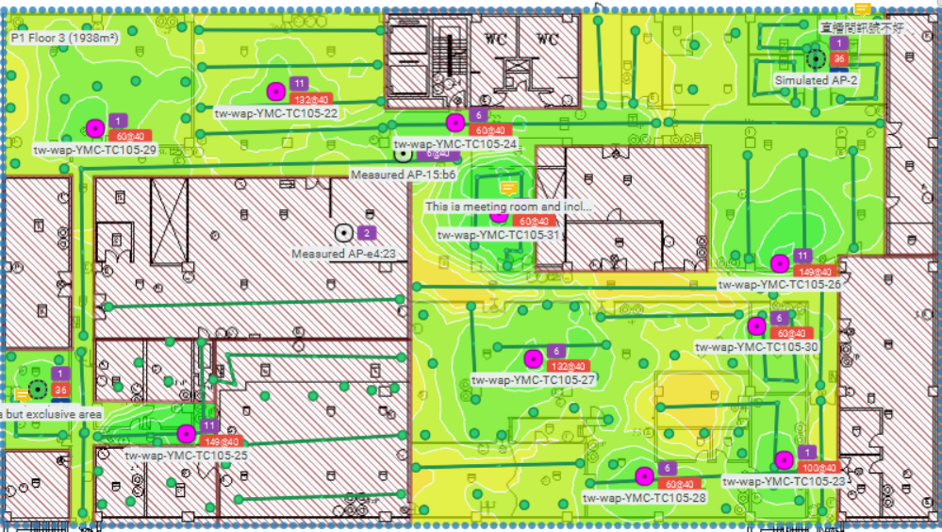

## Building P3 Floor B1

RF Observation summary:

Overall RF Cover and SNR is not good at gray area, but client report it is no issue.

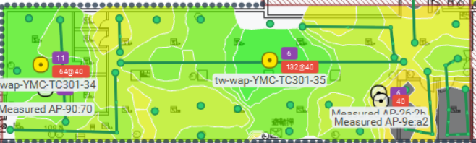

Recommend to adjust as below.

## H Building Floor 2

RF Observation summary:

Overall RF Cover and SNR is very good.

Channel interference on 5GHz band is moderate.

No interfering WAP in this area.

Recommend to adjust as below.

